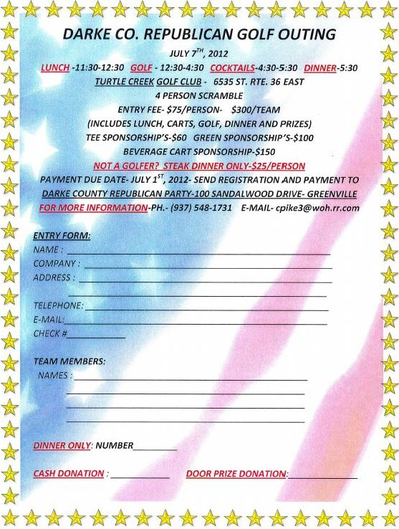

Paid for by the Darke County Republican Party, Treasurer Carol Ginn, P.O. Box 45, Greenville, OH 45331