**Darke County Republican Women’s Club**

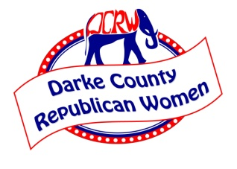

The Darke County Republican Women’s Club is a club dedicated to providing Republican women in Darke County and surrounding areas the opportunity to meet and discuss our conservative values. We meet monthly in Greenville, Ohio, Second Monday in the evening to hear speakers, discuss elections, issues, and candidates. We also help with our local party to ensure strong membership and events.

**Annual Dues:**

$30.00 (if 65 plus years of age)

$35.00 (if under 65 years of age)

**Make check payable to**: DCRW CLUB and send to:

DCRWC, P. O. Box 45, Greenville, Ohio 45331

*\*Spouses can join as Associate Members at the same rate as above*

If you do not want to become a Member at this time but would like to make a donation, the Club would be very appreciative. This would help the DCRW to continue their support of the Republican Nominees.

**I am making a donation in the amount of __________.**

Please fill in the following with your current information.

Name:

Street Address:

City/Zip:

Phone:

Cell Phone:

E-Mail:

Birthday on the ____ day, in the month of ___________ Original Membership year________(approximate)

**Please check as many interest areas/committees that you may have:**

**Standing Committees:**

Ways and Means_______ Social ______ Program ______ Publicity______ Historian _______

**Other Committees:**

Reservations_____ Greeters_____ Chaplain_____ Assistant Chaplain____

OFRW/NFRW Representative w/our President______ or OFRW/NFRW Alternate_____

Legislative_____ By-Laws ______ Handbook Publisher________

**Darke County Republican Women’s Club 2019-20 Officers**

Betty Hill, President Cindy Pike, Treasurer

Lyn Bliss, 1st Vice President Sherry Ward, Recording Secretary

Katie DeLand, 2nd Vice President Wavelene Denniston, Corresponding Secretary

Paid for by Darke County Republican Women, Cindy Pike, Treasurer, P. O. Box 45, Greenville, OH 45331