GUEST SPEAKER FOR DCRW’S CLUB

U.S. CONGRESSMAN WARREN DAVIDSON

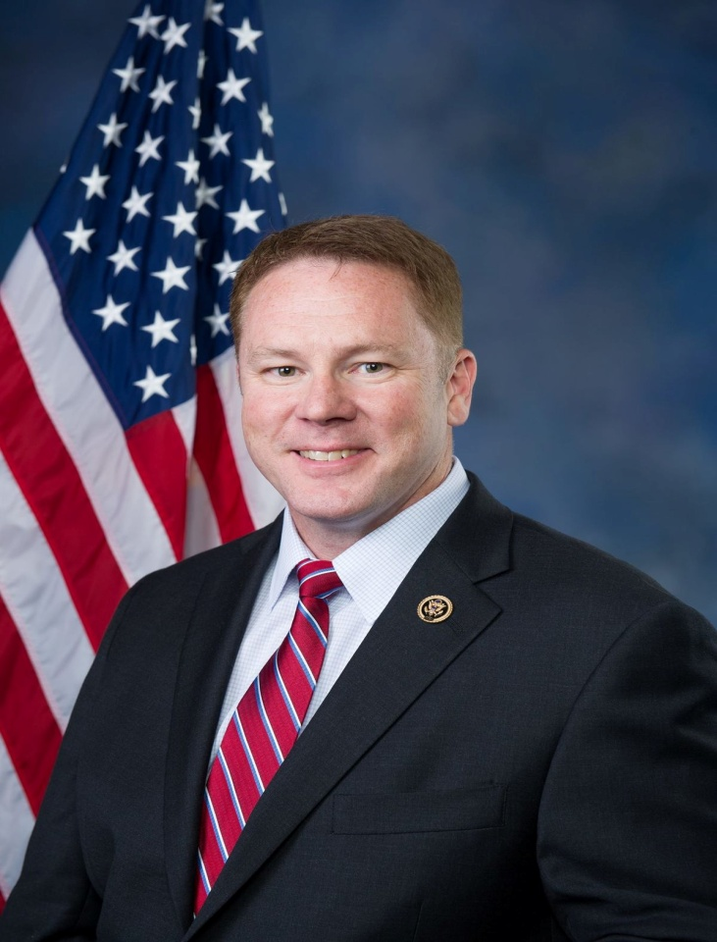

Darke County Republican Women’s Club

Regular Monthly Dinner/Meeting

6:00 P.M. March 12th

Chestnut Village-Brethren Retirement Community

“U.S. Congressman Davidson was born and raised in Sidney. After high school he enlisted in the Army and went on to earn an appointment to West Point. He served in the Old Guard, the 75th Ranger Regiment, and the 101st Airborne Division. He returned to Ohio to help his father’s business. He helped grow one company with 20 employees to multiple companies with over 200 employees. Warren earned an MBA from the University of Notre Dame. He has been married to wife Lisa for more than 20 years, the couple has 2 children. Warren won a special election to fill the remaining term of outgoing US Representative John Boehner and was re-elected to his first full term in November of 2016. Warren sits on the prestigious House Financial Services Committee.”

Public is invited.

If you are interested in hearing Congressman Davidson speak of his experiences join us by calling:

Wavelene at 547-6477 or e-mail her at [wdenniston@woh.rr.com](mailto:wdenniston@woh.rr.com)

before noon on Thursday March 8th