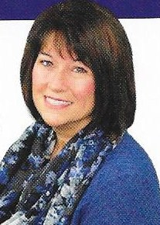

Kristina Heath, Co-Owner

KTL Performance Mtg.

was the Guest Speaker for the

Darke County Republican Women’s Club September Dinner/Business Meeting.

She told of her before and after experiences while becoming the Owner/Loan Officer of KTL which she shares with her husband John Heath.

The DCRW would like to thank the ladies listed below for their participation in our

“Women in Business” project.

These women are all in business locally and we applaud them for their services to our community:

Sonya Crist with Plexus Worldwide Health and Wellness Co.

Kim Bohler, Consultant with Perfectly Posh

Dr. Kylie Young, Owner of Belton

Kirsten Berghoff, Co-Owner Sadie Grace

Rebecca Cotterman, Program Director Big Brothers Big Sisters

and the above

Kristina Heath, Co-Owner KTL Performance Mtg.

The next dinner/business meeting will be

6:30 pm Monday October 9th.

Information regarding that meeting will follow.