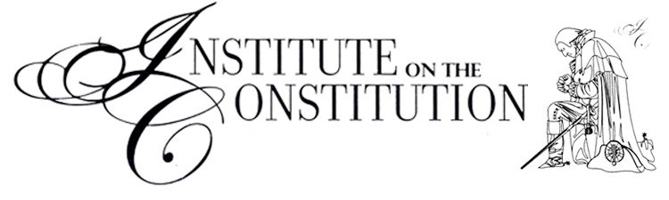

The Truth of America's Founding – Your Heritage and Mine
A Two Day Seminar

MISSION STATEMENT: To demonstrate the role of God and the Bible in the establishment of the United States of America and how our American and Christian heritage is intertwined.

WHERE: Wayne Health Care, 835 Sweitzer St, Greenville, OH
45331 - Third Floor, Conference Room 2.

WHEN: Sat. Mar. 25 & Sat. Apr. 1, 2017 - 9:30 am - 12:30 pm
(Doors open at 9:00 am to pay fees, pick up materials
and be seated.)

COURSE DESCRIPTION - Using the Bible, the Mayflower Compact, the Declaration of Independence, the U.S. Constitution, and other primary sources you will learn:

- Amazing information from Christopher Columbus’s diaries.
- Why the Pilgrims came to America in 1620. (Hint: It wasn’t just for religious freedom.)
- The surprising foundation for American law as stated in the Declaration of Independence.
- Key doctrines of the Constitution that will expose many erroneous modern-day teachings, including what the phrase “Separation of Church and State” really means.
- Modern Day applications: What it would look like if
concerned church and community members worked together Constitutionally to protect LIFE, LIBERTY and PROPERTY.

COMMENT FROM A CLASS ATTENDEE: “It was quite illuminating and has helped me see the Declaration of Independence and Constitution as products of a biblical worldview.”

Cost: Tuition is free; $40 per person or couple for course materials which will be collected at the first session, cash or checks only.
Any high school or college student who wants to attend will only be charged half price for materials ($20.)

Interested? Please contact us by phone or email or complete and return the registration information below.

Registration deadline: Saturday, March 11, 2017

------------------------------------------------------------------------------------

The Truth of America's Founding - Two day Seminar
Course Registration

Sat. Mar. 25 & Sat. April 1, 2017 - 9:30 am - 12:30 pm

Name _________________________________________________

Phone (____)_________________ Cell (____)_________________

Email _______________________________________________

(Emails are very important. We use them to communicate during
and after the course!)

Contact Person:

Keith Threewits
(937) 968-6158
kc3wits@bright.net

-------------------------------------------------------------------------------------------

The information and materials presented at this seminar sets people free and inspires them to Godly action. If you won’t defend liberty, who will? REGISTER TODAY!

