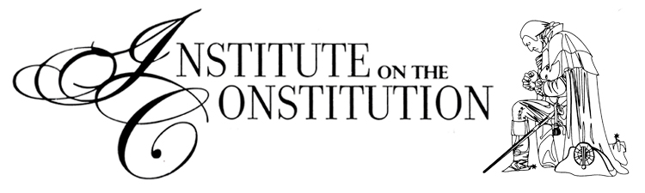
The Truth of America's Founding - Your Heritage and Mine

A Four Lesson Seminar - Syllabus

Mission Statement: Demonstrating the role of God and the Bible in the establishment of the United States of America and how our American and Christian heritage is intertwined.

Lesson-1: The United States of America was founded on Biblical principles, an undeniable fact based on primary source documents:
- 1492 - Christopher Columbus's real reason for sailing west from Spain, writings from his own diary, written in 1502.
- 1620 - The Pilgrims and the Mayflower Compact, America's first government document.
- 1740-1760 - The first Great Awakening and how it impacted some of our key Founders.
- 1776 - The Declaration of Independence - paving the way for the U.S. Constitution - both of which are based on Biblical principles!
- Modern-day applications - What would it look like today if the Church and State worked side-by-side in politics? (Webster's 1828 Dictionary definition of "Politics.")

Lesson-2: Introduction to the U.S. Constitution – arguably the most successful government document in the history of the world.
- The Founders' Biblical World View and the form of government they established for us (A Constitutional Republic, not a pure Democracy!)
- The Preamble to the Constitution.
- Separation of government powers: Where the idea came from and how it separates us from every other nation in world history!
- Article I - The Legislative Branch
- How Article I limits the power to the federal government
- Slavery and the Constitution. Is the Constitution a "pro slavery document?"
- Article II - The Executive Branch
- Modern-day applications - What would it look like today if the Church and State worked side-by-side to protect life?

Lesson-3: The Constitution, Separation of Powers, and the Bill of Rights
- Article III - The Judicial Branch
- The Myth of 3 "Co-Equal" Branches of Government.
- Bill of Rights (First 10 Amendments) with main focus on the First Amendment.
- A discussion of Church, State, and the REAL First Amendment.
- The Changing View of Absolute Standards and Truth - When and how did the United States of America change from the Founders Biblical view of law and government to what we have today?
- Modern-day applications - What would it look like today if the Church and State worked side-by-side to protect liberty?

Lesson-4: Modern-Day Applications - A Game Plan for Action
- Should Christians be involved in Civil (Earthly) Government? What does the Bible say?
- 4 Walls of Godly Jurisdiction from the scriptures.
- What should concerned citizens do? What can we do? A game plan for action!
- What would it look like today if the Church and State worked side-by-side to protect property?

